Create a PO
PO: 500000666727
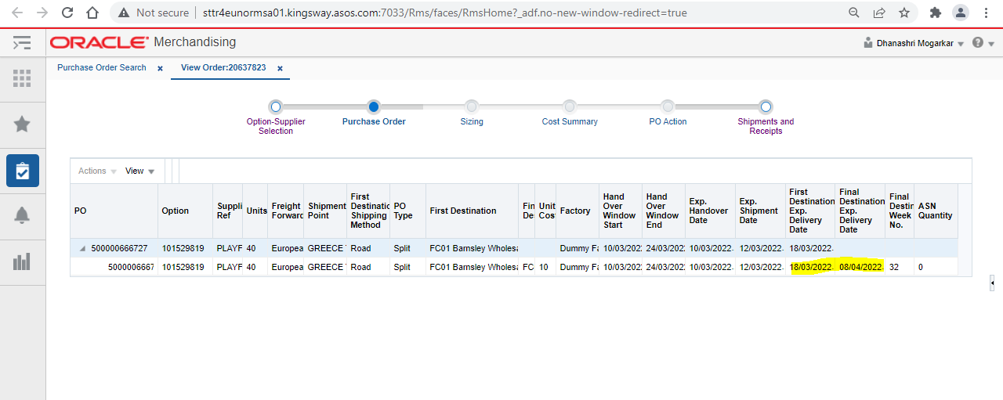Process it SO file through Putty with the date variation(1/2/3 months gap) compared to PO.(in this example we have taken 1 month gap scenario)
Below are the formulas by which you can calculate these variances
For Direct PO final destination despatch month will be calculated as follows -
1. PO without ASN (not_after_date on ordhead table+ default no. of days setup for the warehouse in wp_system_parameter).

2. PO with one or multiple ASN (most recent delivery date on ASN - est_arr_date on shipment table+ default no. of days setup for the warehouse in wp_system_parameter).

3. POs with receipts on ASN (most recent receipt date on ASNs- receive_date on shipment table + default no. of days setup for the warehouse in wp_system_parameter).

For Split PO final destination despatch month will be calculated as follows –

1. PO without ASN (in_store_date on alloc_detail table+ default no. of days setup for the warehouse in wp_system_parameter).

2. PO with one or multiple ASN (most recent delivery date on ASN - est_arr_date on shipment table+ default no. of days setup for the warehouse in wp_system_parameter + transportation days set in MA_TRNSP_TRANSIT_MATRIX for first and final destination).

3. POs with receipts on ASN (most recent receipt date on ASNs- receive_date on shipment table + default no. of days setup for the warehouse in wp_system_parameter+ transportation days set in MA_TRNSP_TRANSIT_MATRIX for first and final destination).
Once you process the file you can see same details in database as below
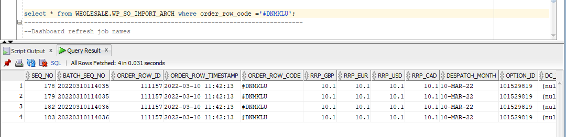

Now refresh the dashboard by running a Putty command and you will be able to see that record in dispatch window variance dashboard as follows under green color
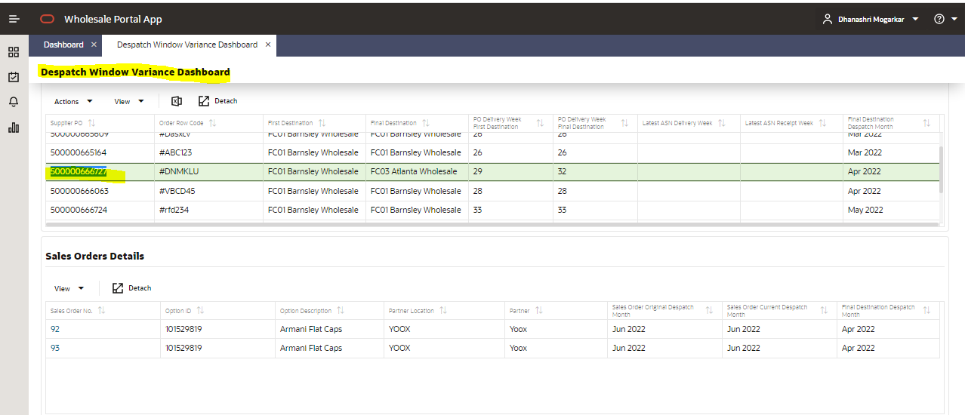

Red Colour Tile
If you want your data to reflect in red colour, you need to give 2 months gap in your despatch month
PO: 500000665612
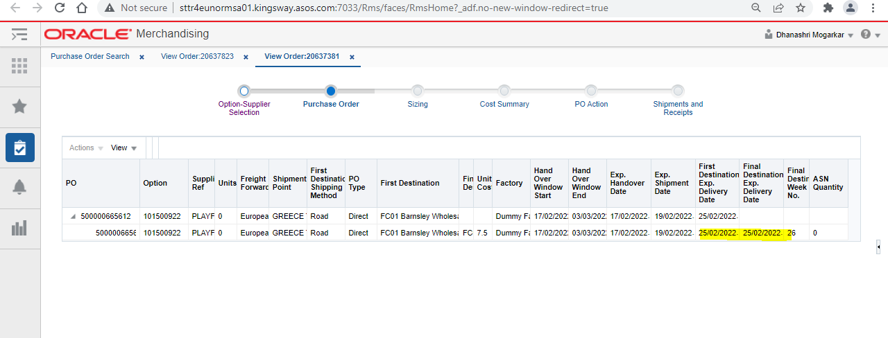
Calculate the month variance as per the formulas given above and process the SO file through Putty
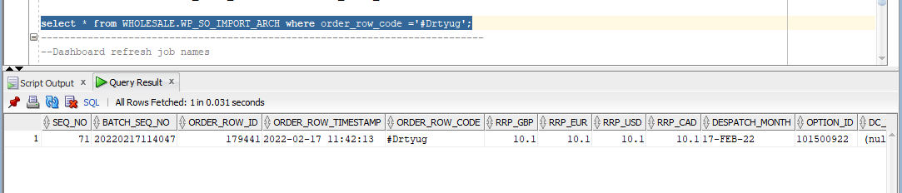

Now refresh the dashboard by running a Putty command and you will be able to see that record in dispatch window variance dashboard in red color tile as follows
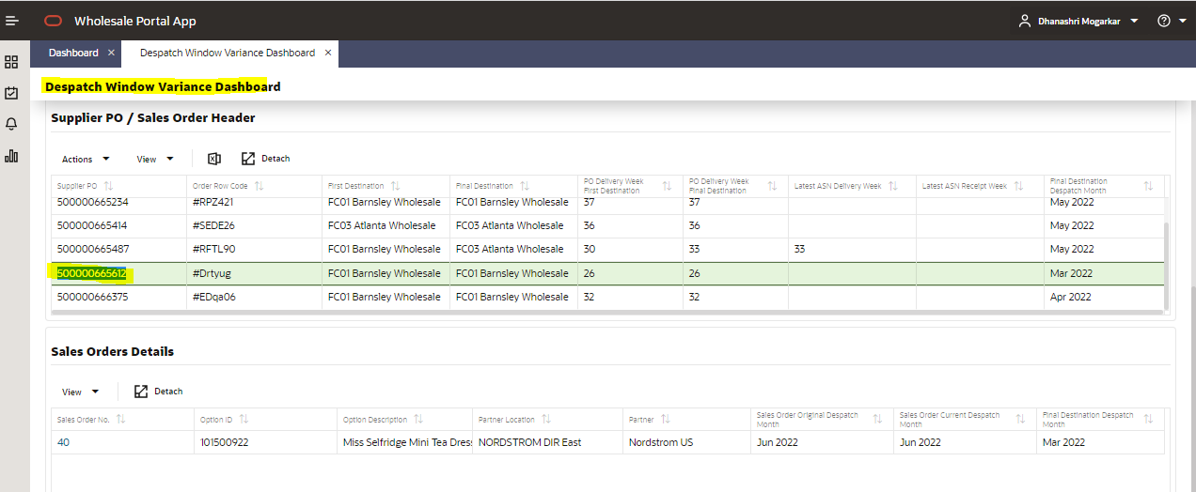

Orange color Tile
If you want your data to reflect in orange colour, you need to give 3+ months gap in your despatch month
PO: 500000666295

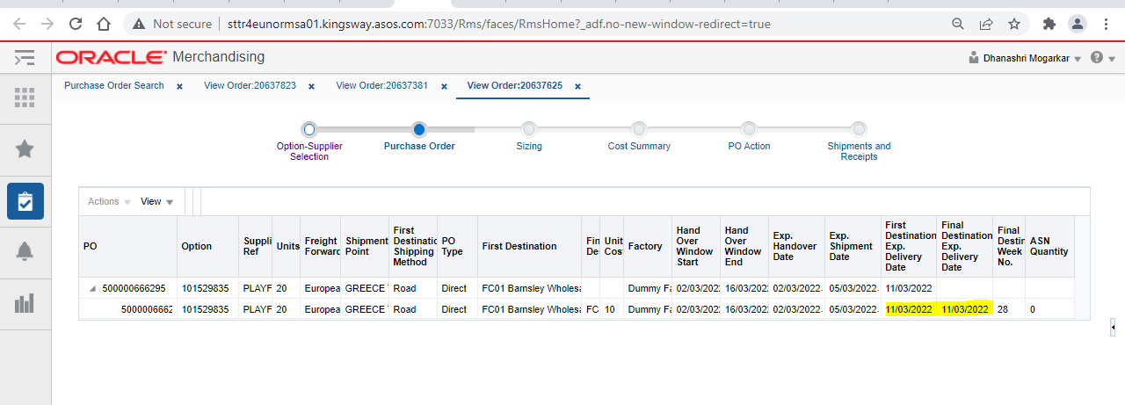
Calculate the month variance as per the formulas given above and process the SO file through Putty
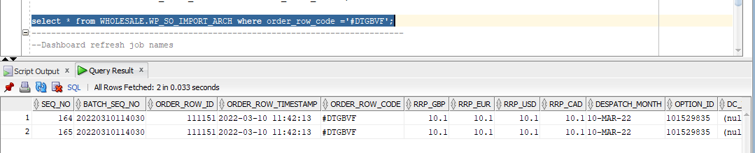

Now refresh the dashboard by running a Putty command and you will be able to see that record in dispatch window variance dashboard in orange color tile as follows
